Text and Date Queries

Using: Like, in, is null, is not null, between, distinct, >, >=, <, datediff function

# **Practice Exercises**

Use the Northwind database.

1. Find the Territory names that contain the word ‘Santa’ [Use the Territories Table]

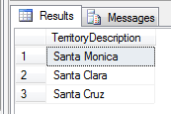

1. Display the Territory names that begin with the letter ‘C’. [Use the Territories Table]

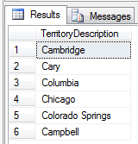

1. Display the territory names that contain ‘boro’. [Use the Territories Table]

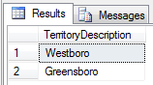

1. Display the names and job titles (ContactTitle) of contacts who are also owners. [Use the Customers table]

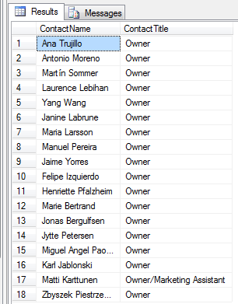

1. Display the company names and the URLs of those suppliers that have websites. [Use the Suppliers table]

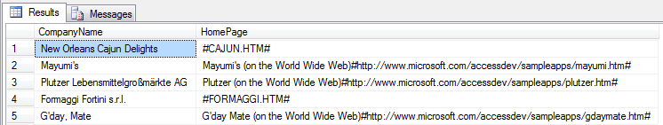

1. Display the company names and the URL column of those suppliers that don’t have websites. [Use the Suppliers table]

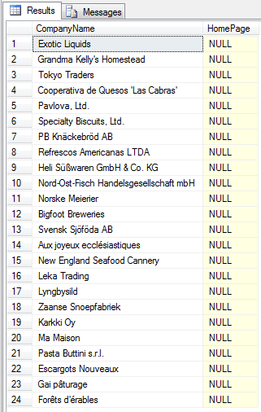

1. Display the names and prices of those products with prices of $50 or more. [Use the Products table]

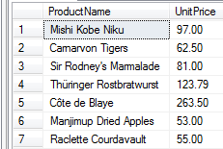

1. Display the names and prices of those products with prices less than $10. [Use the Products table]

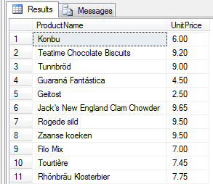

1. Display the names and prices of those products with prices of $10 or less. [Use the Products table]

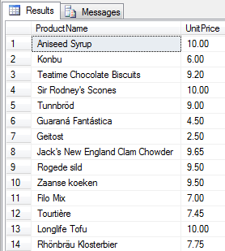

1. Display the names and prices of those products with prices greater than or equal to $15 but less than or equal to $20. [Use the Products table]

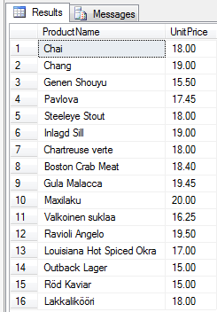

1. Display the names and ages of all employees. [Use the Employees table]

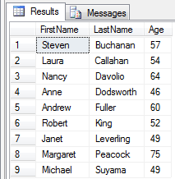

1. Display the freight total. [Use the Orders table] **Use Group By**

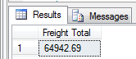

1. Display the 1996 freight total. [Use the Orders table] **Use Group By**

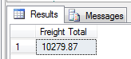

1. Display the 1997 freight total. [Use the Orders table] **Use Group By**

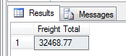

1. Display the 1998 freight total. [Use the Orders table] **Use Group By**

